

Department: Land Affairs

REPUBLIC OF SOUTH AFRICA

SURVEYOR-GENERAL: CAPE TOWN

P/ Bag X 9028 90 Plein street, C. T. 8001 Tel (021) 467 4800 Fax (021) 465 3008 Prints (021) 465 7358 Accounts (021) 465 7361

E-mail: sgcape@lg021.wcape.gov.za

AUTOEMAILER

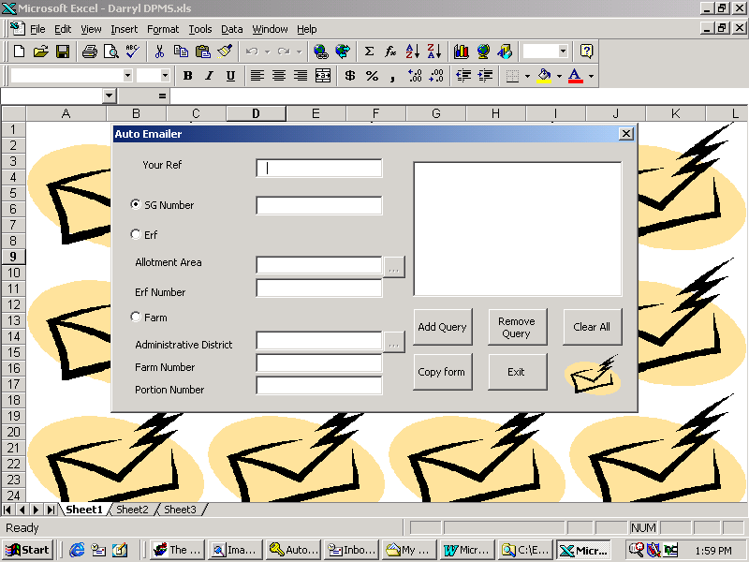
Herewith the procedure to follow to get images automatically.
1
2
3
4
5
6
7
8
9
10
11
12
13
14
Add your reference to the text box labeled “Your ref”. (1)

Add diagram numbers as follows:
- Click the Diagram radio button on. (2)
- Add the Diagram number (see also below). (3)
- Click the Add Query button to add this to the list. (11)

The diagram number field can be used to add:
- Diagram numbers. Transkei diagrams must be prefixed with a TR, e.g. TR155/1995. Ciskei diagrams will need to be prefixed with a C, e.g. C15/1994. Servitudes will also need to called up using their diagram number.
- Survey record numbers (must be prefixed with SRE e.g. SRE122/2001)
- Sectional title number (only the D number can be added and must be prefixed with a D, e.g. D155/2002). For pre-act sectional titles prefix the diagram number of the underlying erf with a D, e.g. D1234/1998.
- GPs can only be called up using their diagram number; or else you will need to query an erf that falls on the general plan.
- Noting sheet numbers. Just add the filling number, e.g. 1324 for imperial and M724 for metric.

Add erf numbers as follows
- Click the Erf Number radio button on. (4)
- Click the little button on the right with the “…” (5) and choose the Allotment area (on the new form, and then click OK on this new form).
- Add the erf number. (6)
- Click the Add Query button to add this to the list. (11)

Add farm numbers as follows
- Click the Farm Number radio button on. (7)
- Click the little button on the right with the “…” (8) and choose the Administrative District (on the new form, and then click OK on this new form).
- Add the farm number. (9)
- If there is a portion, add the portion number. (10)
- Click the Add Query button to add this to the list. (11)

The remove query button (12) can be used to remove a query from the list. First select the query to be removed before clicking this button.

The clear all button (13) can be used to clear the whole list.

Please try to keep your requests down to around five items, as the return email may be fairly large and could take a while downloading on your side.

Once you are ready to send the email click on the copy form button (14). This will bring up the “Copy contents to email form”.

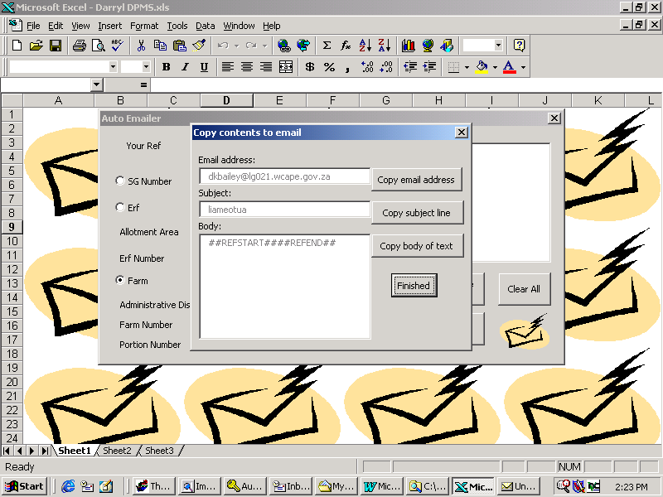
15
16
17
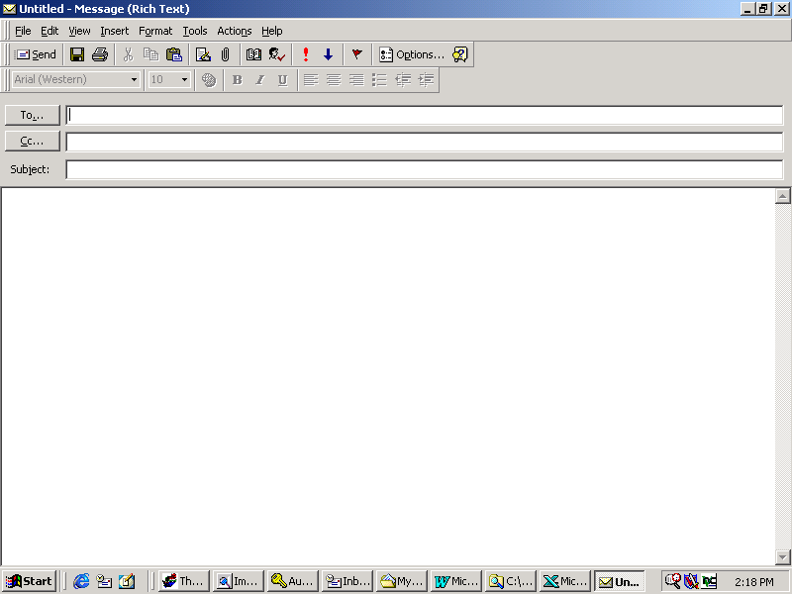
18
19
20
On this form click the copy email address button (15) and then go to your new email message and click in the “To” (18) field and then click paste to paste this address into this field.

Go back to Excel and click the copy subject line button (16) and then go to your new email message and click in the “Subject” (19) field and then click paste to paste the subject into this field.

Go back to Excel and click the copy body of text button (17) and then go to your new email message and click in the “Body of Text” field (20) (where you would normally write your email message) and then click paste to paste the text into this field.

You can now send your email (remember you must be connected to send and receive email).

I have now added a button “Create Email” which should automatically create the email for you. This only works in Outlook (not Outlook Express though). If you have a whole lot of text in the subject line, then you need to copy this into the body of text to get it to work. Then send the email.

You should get a reply from our office within about ten minutes.

Prepared by Darryl Bailey,
Client Services Centre,
Surveyor-General’s Office : Cape Town

Departement van Grondsake Kgoro ya tsha Naga Umnyango wezoMhlaba

