The new Auto e-mail program is only a spreadsheet with macros, which if sent to a specific e-mail address will interact with the servers and then reply with images attached without any human intervention.

See images below as an example of how the program works. Image 1 is the first screen after the macros have been enabled. The following images are just an indication of how the screens are supposed to look in sequence.

Tips on using the program.
The S.G. no. option can be used for Diagrams, General Plans, Sectional titles and compilations of which the numbers are known to the user.

Entering of numbers for the Gp’s and Diagrams as follows. Before the year1900, all numbers must be without any prefix for example 123/1890. From the year 1900 until 1994 the numbers must have an “A” before the number eg. A123/1994. From 1995 the prefix falls away and only the number must be added again eg. 123/1995.

For sectional titles a prefix “D” must be added to all scanned Sectional Title plans for example D123/1994. Only plans examined by the SG under sectional titles act of 1986 are scanned at this stage.

For compilations, the number must all be capital letters without any spaces for example JRSM12 or JR5C12A.

If the SG no. is not available, farm and erf diagrams can still be ordered by using the other 2 options. By clicking on the 3 dots next to Minor region or Registration Division a list will appear were the relevant township or registration division can be chosen from. Erf/farm and portion numbers can then be added to the query and then the steps are the same as with the SG no. All 3 options can be used on the same request but must be “add to Query” separately.

Information about the program.
Only 3MB of data may be made per order, but as many orders as necessary may be sent. (reply message will indicate that data requested is more that 3MB)

If a message is retured saying that the image is not scanned please try in 3 days time, it can be either 1. Not scanned. 2. Does not exist. We can at this stage not re-act to the message and will appreciate it if you can place the order at sgdata@012lg.pwv.gov.za. That way we will know that there is a problem.

Feedback from trial users indicates the following problems.
Some service providers or email programs put the info in the wrong place. (See last image for the correct way.) In the To box there must be alpheusl@012lg.pwv.gov .za. In the Subject box it must be liameotua (autoemail backwards) And in the Data box something like ##start##dgm123/1995##end####refstart####refend##. If any of the above differs there is a function “copy form” Open a blank e-mail and copy the information to the e-mail.

Image 1

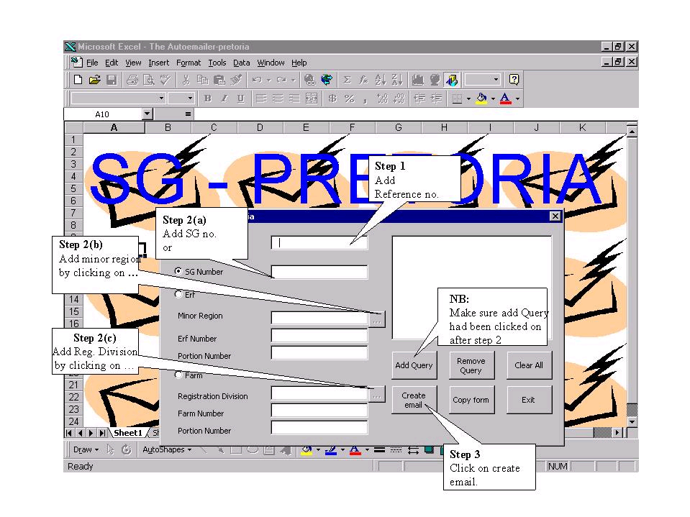

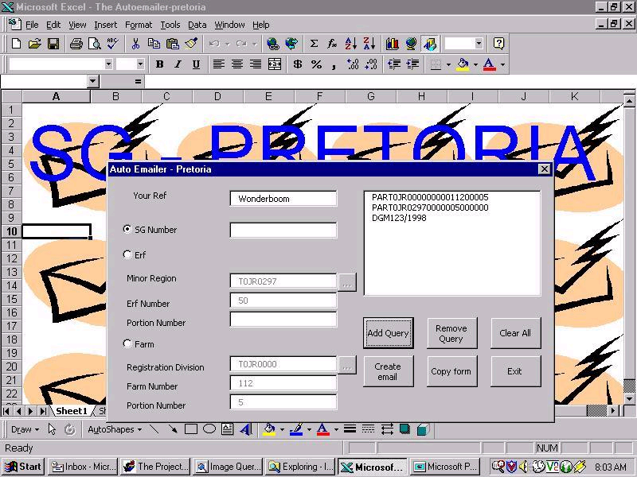
Image 2
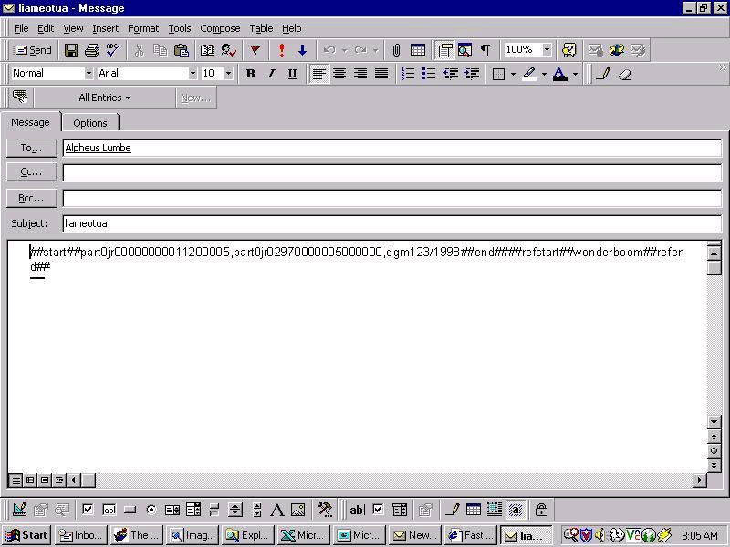

Image 3

